Create app todo list parcial

1. Créate expo proyect

In the terminal app, execute next commant



1. Install dependeces for navigation





1. Create estructure for the app

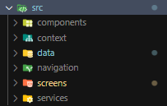

1. Create files for the app

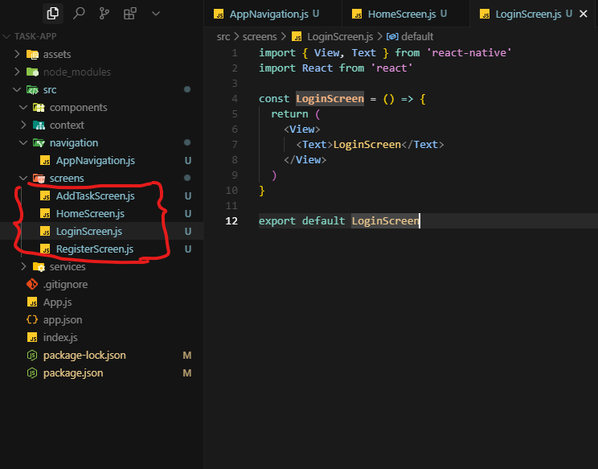

1. Create the file for the navigation configuration in the application

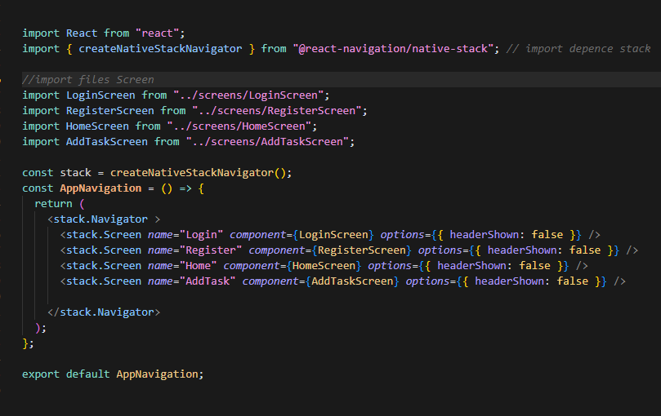

1. Using navigation in the origin app 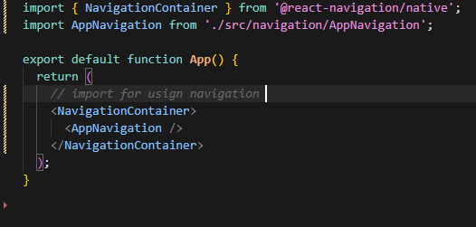
2. create view for loginScreen

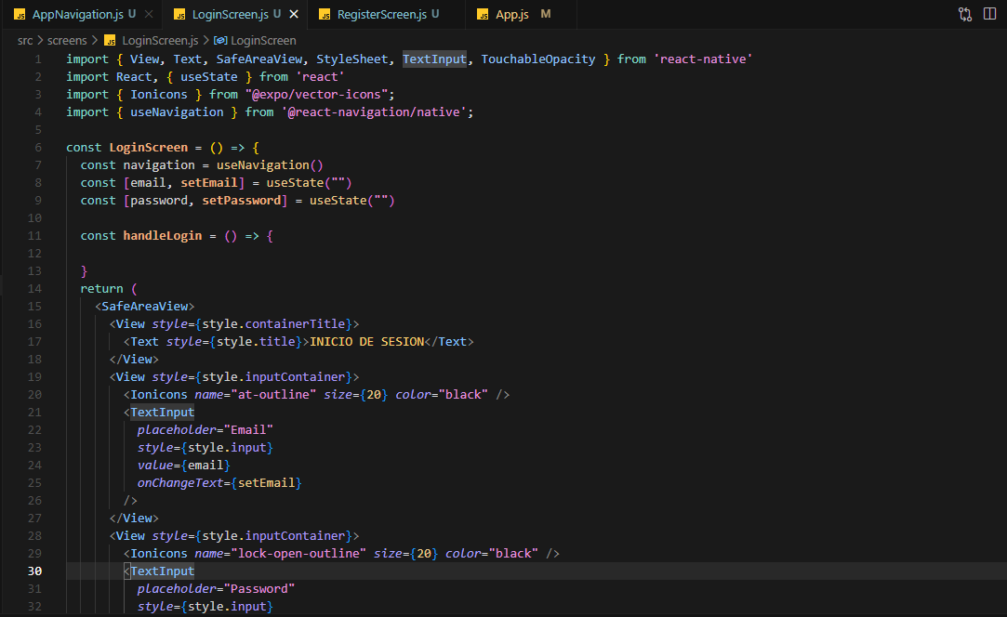

1. créate view for Register Screen

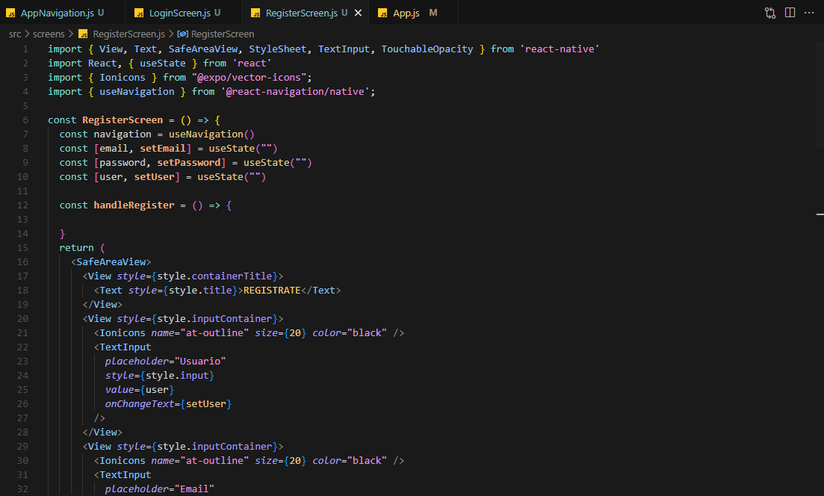

1. créate file .env for the environment variables

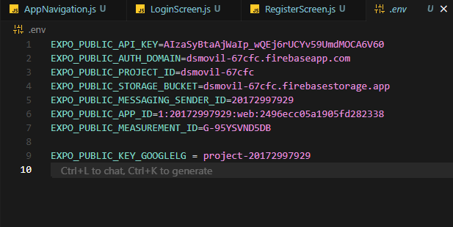

1. Install dependeces for using firebase





1. Create file for config firebase

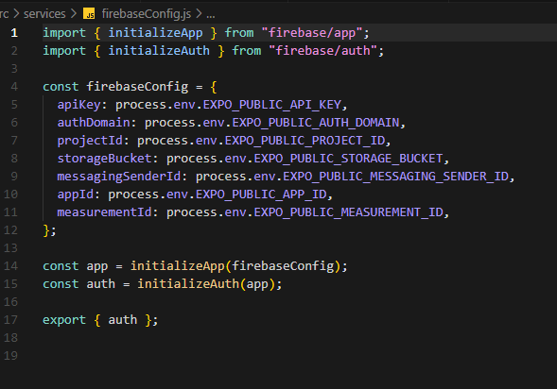

1. Create a Firebase login function

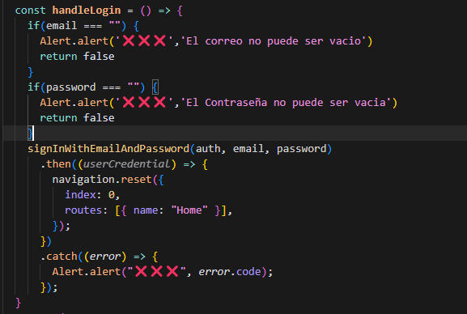

1. Créate a firebase register function

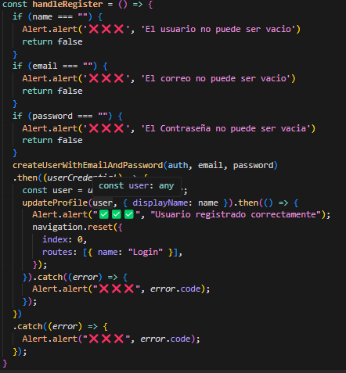

1. Install dependece for async storage   
   
2. Create the task actions in a separate file for better control of them

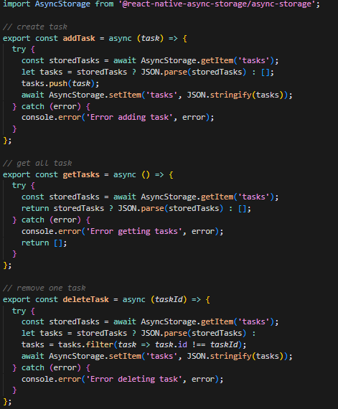 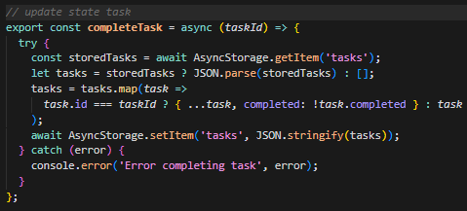

1. Create the design of the HomeScreen view with its navigation actions, and actions for completing and deleting tasks

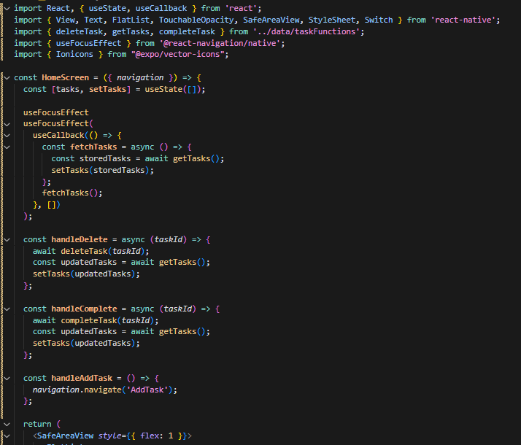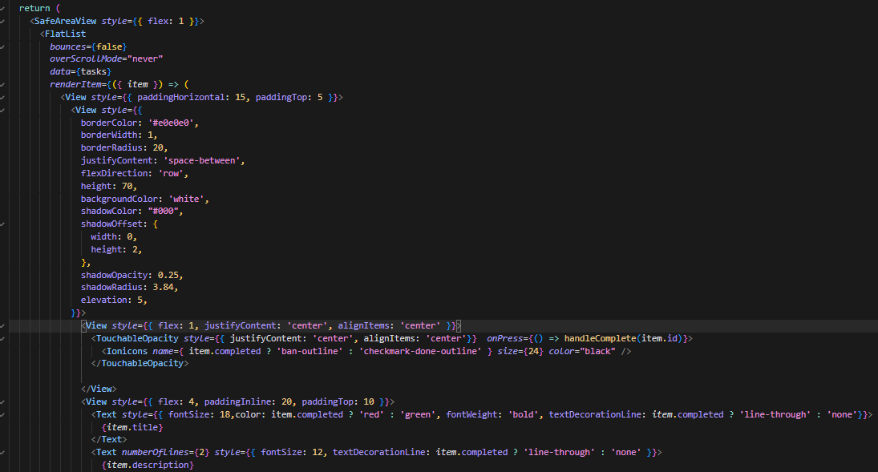 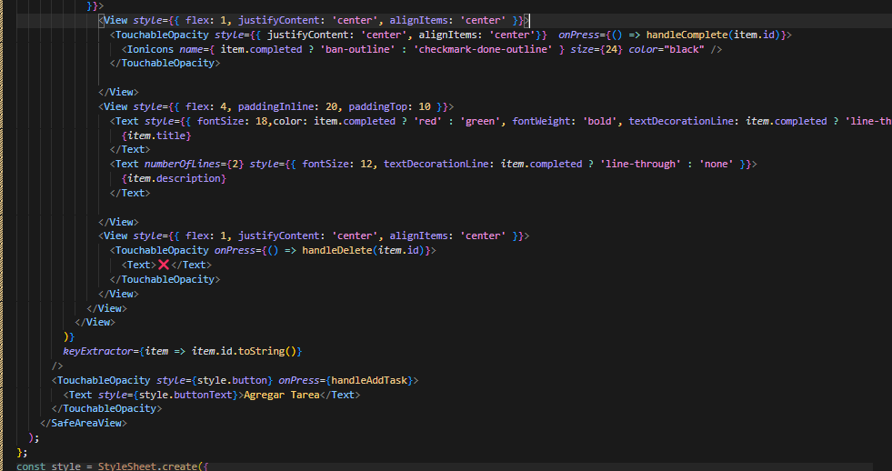

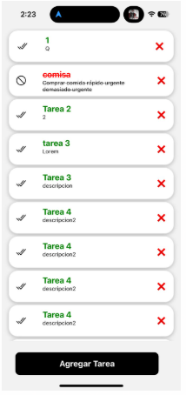

1. Create the design of the AddTaskScreen view with its navigation actions and task creation actions

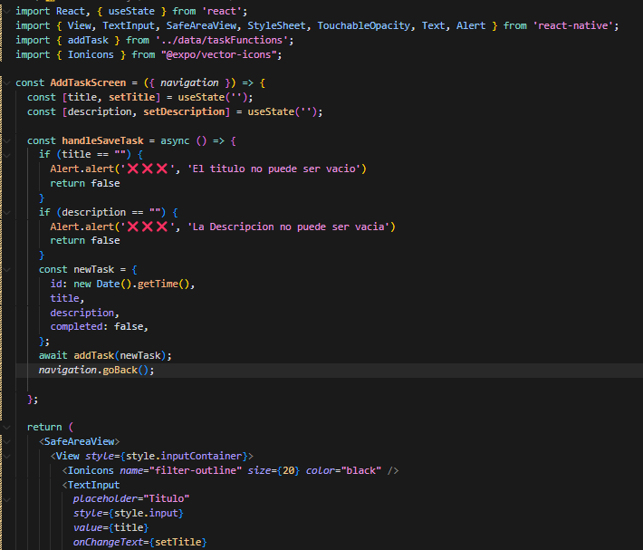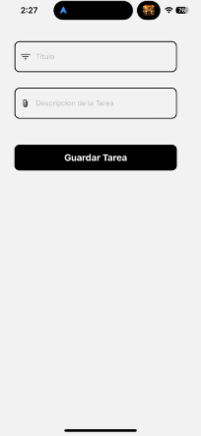

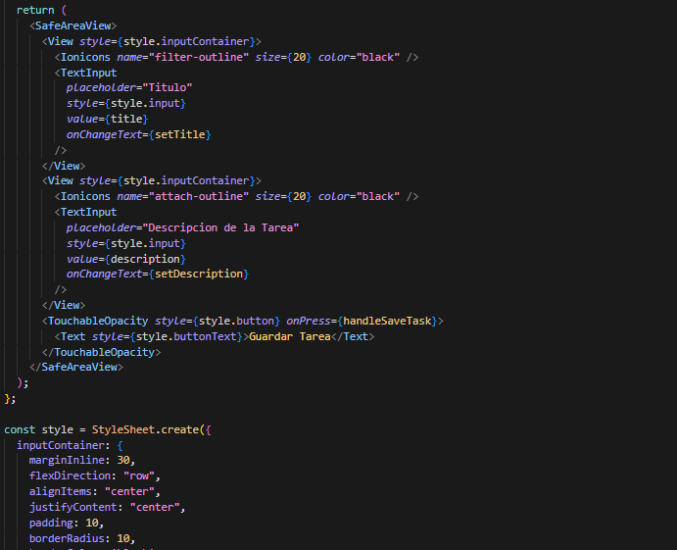

1. Implement button logout

